

Cecil Andrews College

Year 11
ATAR
Human Biological Science

Test 3

Digestive and Excretory Systems

Total Marks = 95

Section A. Multiple Choice (25 Marks)
Circle the most appropriate response

Section B. Short Answer (60 Marks)
Place responses in the spaces provided

Section C. Extended Answer (10 Marks)
Place responses in the spaces provided

Name: _____________________________________

Section A – Multiple Choice (Total 20 Marks)

Select the best answer from the alternatives. Circle your answer on this paper.

- The main function of the bladder is to:

  - absorb vitamins.
  - reabsorb water from urine.
  - reabsorb mineral ions from urine.
  - store urine before it is voided.

- Which group represents excretory products found in humans?

  - Glucose, urea, bile salts, amino acids.
  - Water, plasma, urea, carbon dioxide.
  - Carbon dioxide, urea, salts, water.
  - Carbon dioxide, undigested food, salts, water.

- The lungs and intestines have similar structures related to all of the following except:

  - A large surface area enabling rapid diffusion of molecules into the blood.
  - A thin surface lining separating the internal and external environments.
  - A rich supply of blood.
  - A large number of air spaces between the cells to reduce the weight of the organ.

- Which of the following is the best definition of excretion?

  - Excreta is eliminated from the digestive tract.
  - Metabolic wastes from cells are removed from the body.
  - Urea is produced in the liver.
  - Deamination occurs in the liver.

- In a normal healthy person, glucose is not normally found in the urine because:

  - glucose is too large a molecule to be filtered by the kidneys.
  - glucose is used in respiration to produce energy for movement.
  - glucose is reabsorbed after the filtration process and passed back into the blood
  - excess glucose is converted to glycogen and stored in liver and muscles.

- After digestion and absorption into the villi of the small intestine, which of the following nutrients would enter the blood stream via the lymphatic system at the thoracic duct?

  - Sugar.
  - Amino acids.
  - Lipids.
  - Vitamins.

- Haemodialysis is a treatment used by someone who has kidney failure. It involves:

  - surgical replacement of a diseased kidney.
  - passing blood through a dialysis machine where filtration occurs before it is passed back in to the body.
  - a catheter is inserted into the peritoneum and filtration occurs inside the catheter.
  - enzymes that break down urea are injected into the body.

- The tube which connects the kidney to the bladder is called the:

  - fallopian tube.
  - vena cava.
  - ureter.
  - urethra.

- The excretory system consists of:

  - The lungs, the stomach, the kidneys and sweat glands.
  - The kidneys, the lungs and the sweat glands.
  - The kidneys, the lungs, the alimentary canal and the sweat glands.
  - The lungs, the kidneys, sweat glands and the pancreas.

- Proteins are composed of smaller units called

  - fatty acids
  - glycerol
  - amino acids
  - monosaccharides

- The series of muscular contractions that moves food along the digestive tract is called

- periostesmis
- peristalsis
- perilstalsis
- peristopsis

- The stomach connects directly with the

- jejunum
- ileum
- duodenum
- caecum

- The process of digestion can best be described as

- the release of energy from food
- the breakdown of organic molecules
- the absorption of organic molecules into the bloodstream
- the breakdown of the food in the stomach

- Which of the following enzymes is responsible for the digestion of carbohydrates?

- Pepsinogen
- Protease
- Amylase
- Lipase

- Which of the following elements occurs in proteins but is not generally found in carbohydrates or fats?

- Carbon
- Hydrogen
- Oxygen
- Nitrogen

16. The function of the liver in digestion is to:

- produce bile
- digest proteins
- store bile
- emulsify fats

18. Hydrochloric acid in the stomach:

- is a symptom of a digestive disorder.
- is a digestive enzyme which hydrolyses fat.
- assists in the digestion of starch.
- contributes to the chemical digestion of protein.

19. The part of the digestive tract where absorption of water and vitamins occurs is the:

- large intestine
- small intestine
- stomach
- pancreas

21. Which enzyme is matched up with the proper function?

- Lipase breaks down fats.
- Amylase breaks down protein.
- Acid breaks down carbohydrates.
- Chyme breaks down all of the above.

For questions 22 and 23, refer to the graph below showing the activity of two different enzymes found in the human digestive tract;

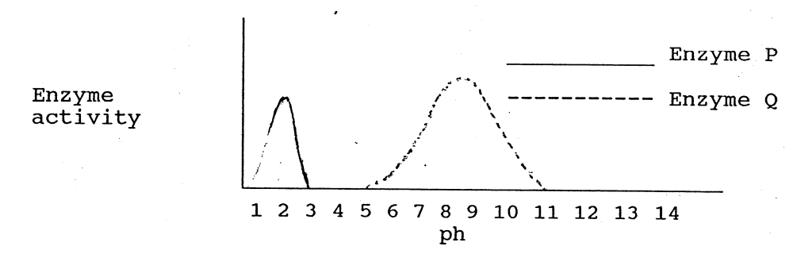

22. Enzyme P is most likely to be:

- Ptyalin
- Lipase
- Gastric protease
- it is impossible to say

23. Which of the following statements about P and Q is true?

- Enzyme P is most active in an acidic medium and enzyme Q is most active in an alkaline medium
- Enzyme Q will only be activated in one part of the digestive tract however enzyme P will be active all along the digestive tract
- Enzyme Q will only break down carbohydrate however enzyme P will break down carbohydrate, protein and lipids
- Enzyme P will be active over a wider pH range than enzyme Q

24. Bile is secreted into the duodenum. Its function in digestion is to:

  - chemically digest lipids.
  - neutralise the acids of the stomach.
  - emulsify fats.
  - complete the digestion of proteins.

25. The removal of metabolic wastes from the body is termed:

- respiration
- excretion
- elimination
- digestion

SECTION B – Written Answers

Write all answers in the spaces provided. Total = 45 Marks

- Terminology
Complete the table using the best scientific term that matches each statement.

Projections which cover the surface of the villus

The acid which is secreted into the gastric pits in the stomach

Type of wastes excreted by excretory system

Arteriole that enters the kidney

A disease in which glucose frequently appears in the urine

Knot of capillaries where blood is filtered of all substances except red blood cells and large proteins

Chemical process in which nutrients are broken down into small molecules so they can be absorbed by the body
The organ which produces bile using the haemoglobin in worn out red blood cells
Proteins are long chains of smaller sub-units called

Small finger-like projections that line the small intestine

The contraction of muscles which moves food along the digestive tract
Structure which stores urine

Organ responsible for filtering blood

Process performed in the liver which breaks down proteins
Undigested food eliminated by the body

(15 Marks)

- Label the diagram of the urinary system below.

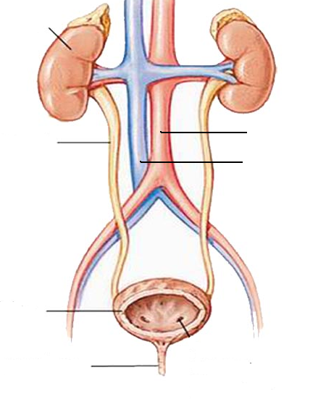

(3 Marks)

- Complete the table below:

Food Type  (substrate) | Where chemical digestion occurs | Enzyme  involved | Food Source  (one example) | End product  of chemical  digestion
stomach
small intestine
 |  | amylase
 |  |  | butter

(6 Marks)

- Use the diagrams below to answer the following questions.

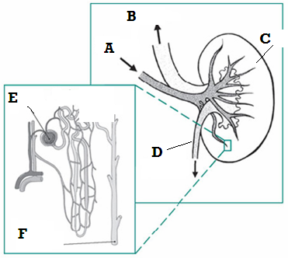

  - Structure A is the: ____________________________________________
  - Structure D is the: ____________________________________________
  - Structure E is the: ____________________________________________
  - Structure F is the: _ ___________________________________________
(2 Marks)

  - Name the structural unit which includes E and F _________________________
(1 Mark)

  - What is the function of this structure? _________________________________
______________________________________________________________
(1 Mark)

  - List the main components that make up urine.
    - ___________________
    - ___________________
    - ___________________ (3 Marks)

- The table below shows a comparison of the concentration of various substances in the plasma, the filtrate and urine. Use the following descriptions to complete the Filtrate and Urine columns of the table.

- None present
- Higher than plasma
- Lower than plasma
- Same as plasma

Substance | Plasma (g/100mL) | Filtrate (g/100mL) | Urine (g/100mL)
Amino acids | 0.05
Glucose | 0.10
Proteins | 8.00
Salts | 0.72
Urea | 0.02

(5 Marks)

- How is mechanical digestion different to chemical digestion?
______________________________________________________________________________________________________________________________________
(2 Marks)

- Describe the mechanical digestion that takes place in:

  - The mouth ______________________________________________________
  - The stomach ____________________________________________________
  - The small intestine ________________________________________________
(3 Marks)
- What is the function of saliva? ________________________________________
______________________________________________________________________________________________________________________________(2 Marks)

7. What is absorbed by the large intestine? ________________________________
(1 Mark)

- What are two factors that influence the efficiency of enzymes in digestive reactions?

- ________________________________
- ________________________________
(2 Marks)

9. Name the four basic activities of the digestive system:

- ________________________ b) ___________________________

c) ________________________ d) ___________________________

(2 Marks)

10. Name the structure shown in the diagram below? ______________
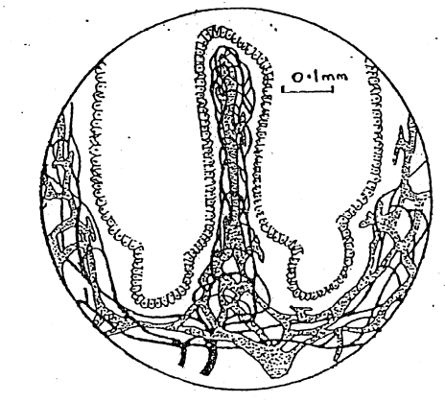
(1 Mark)

11. Describe the main function of this structure? _____________________________
______________________________________________________________
(1 Mark)

12. Describe two ways in which this structure is suited to its function.

    - ______________________________________________________
    - ______________________________________________________
(1 Mark)

- Explain the difference between the terms ‘excretion’ and ‘elimination’.
________________________________________________________________________________________________________________________________________________________________________________________________
(2 Marks)

- Why is concentrated urine more harmful than diluted urine? __________________________________________________________________________________________________________________________________________

(2 Marks)

13. Complete the table to label the diagram below.
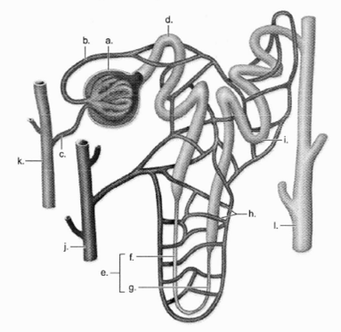
(5 Marks)
a
b
c
d
f
g
h
i
j
k

SECTION C – Extended Answer (Total 10 Marks)

1. Describe how the excretory system regulates the chemical composition of body fluids. In your answer discuss the role of the kidneys, liver, lungs and skin.

